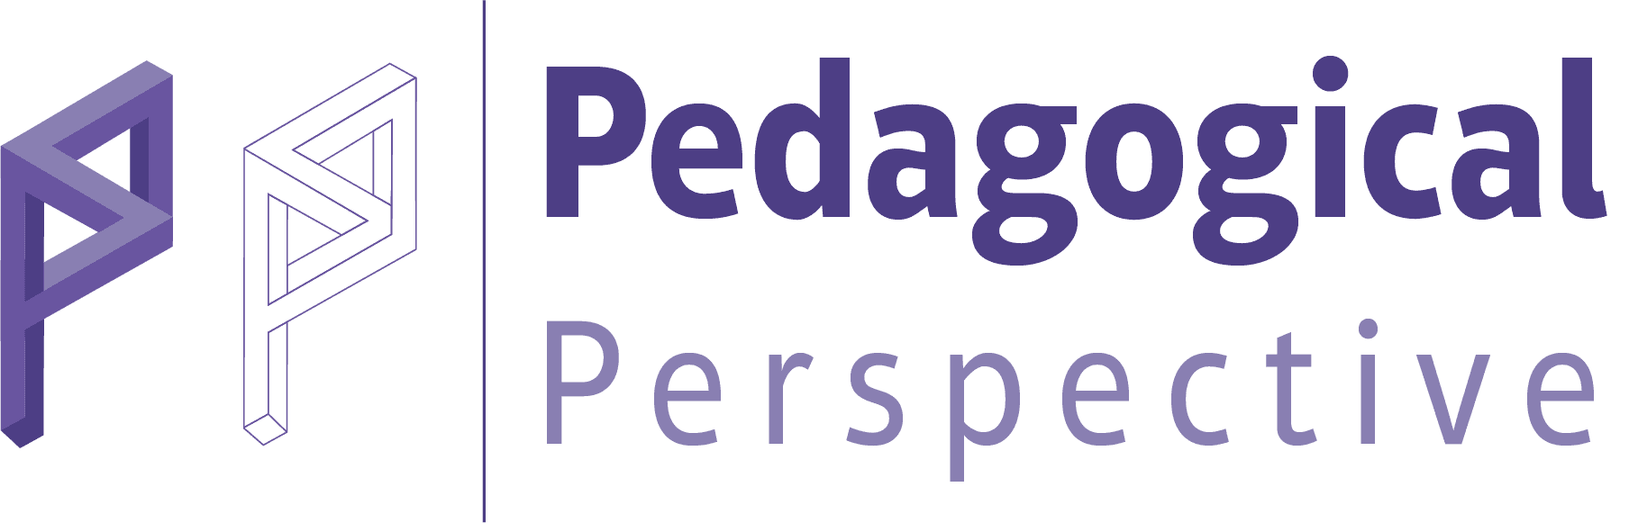 | PedPer Article Withdrawal Form (Authors)

Dear Chief Editor,
I would like to withdraw my manuscript from further consideration by Pedagogical Perspective (PedPer).
Yours Sincerely,

Full name of corresponding author: | Signature | Date

Contact address of corresponding author:
The manuscript ID:
Date of submission:
Title of paper:

Reason(s) of withdrawal:

Other authors’ consent:

Full name | Consent | Signature | Date
 | I agree with the withdrawal
 | I agree with the withdrawal
 | I agree with the withdrawal
 | I agree with the withdrawal
 | I agree with the withdrawal
Please note that: (*PedPer is charged only in case of withdrawal after 15 days of submission of the manuscript).
• An article cannot be withdrawn after the corresponding author has been intimated about its acceptance for publication, by the editorial office.
• The Chief Editor must be informed with an Article Withdrawal Form signed by all authors indicating valid rationales.
• A submitted manuscript will not be withdrawn from peer review until a withdrawal request form has reached the editorial office.
• Authors must not assume their manuscript withdrawn until they have received an acknowledgement letter from the editor’s office.

