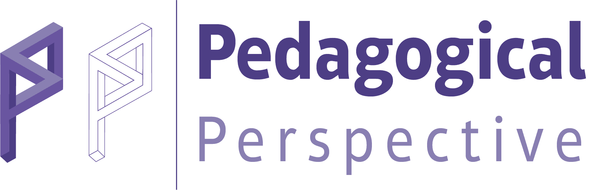 | PedPer Article Withdrawal Form (Authors)

Dear Chief Editor,
I want to withdraw my manuscript from Pedagogical Perspective (PedPer) for further consideration.
Yours Sincerely,

Full name of the corresponding author: | Signature | Date
Metin girmek için buraya tıklayın veya dokunun. |  | Click or tap to enter a date.
Contact address of the corresponding author: | Metin girmek için buraya tıklayın veya dokunun.
The manuscript ID: | Metin girmek için buraya tıklayın veya dokunun.
Date of submission: | Metin girmek için buraya tıklayın veya dokunun.
Title of paper: | Metin girmek için buraya tıklayın veya dokunun.

Reason(s) of withdrawal:
Metin girmek için buraya tıklayın veya dokunun.

Other authors’ consent:

Full name | Consent | Signature | Date
Metin girmek için buraya tıklayın veya dokunun. | I agree with the withdrawal |  | Click or tap to enter a date.
Metin girmek için buraya tıklayın veya dokunun. | I agree with the withdrawal |  | Click or tap to enter a date.
Metin girmek için buraya tıklayın veya dokunun. | I agree with the withdrawal |  | Click or tap to enter a date.
Metin girmek için buraya tıklayın veya dokunun. | I agree with the withdrawal |  | Click or tap to enter a date.
Metin girmek için buraya tıklayın veya dokunun. | I agree with the withdrawal |  | Click or tap to enter a date.
Please note that: (*PedPer is charged only in case of withdrawal after 15 days of submission of the manuscript).
• An article cannot be withdrawn after the corresponding author has been intimated about its acceptance for publication, by the editorial office.
• The Chief Editor must be informed with an Article Withdrawal Form signed by all authors indicating valid rationales.
• A submitted manuscript will not be withdrawn from peer review until a withdrawal request form has reached the editorial office.
• Authors must not assume their manuscript has been withdrawn until they have received an acknowledgment letter from the editor’s office.

